European Environmental Bureau: German medium-sized company
STIEBEL ELTRON is "Leader" of the Energy Transition 2023
• EEB has examined the product range of heating manufacturers for climate friendliness
• Entire Stiebel Eltron portfolio compatible with climate targets
Stiebel Eltron is one of the leading suppliers of climate-friendly heating technology in Europe: the entire product range of the German medium-sized company is compatible with climate targets. According to market analysis by the European Environmental Bureau (EEB), companies in this "Leaders" group are leading the energy turnaround in boiler rooms - they are already setting stricter standards for their own technologies than required by law. The European Environmental Bureau (EEB) has examined the portfolios of the largest heating manufacturers on the European market and rated the best companies with "Leader" status.

"We are delighted to receive this award from the European Environmental Bureau, which already recognises all Stiebel Eltron appliances as climate-friendly," says Dr. Kai Schiefelbein, Managing Director of the Stiebel Eltron Group. "Environmentally friendly heat pumps hvae been the central recipe for success in our company history for decades. On this basis, we are now an experienced specialist for the energy turnaround in boiler rooms."

Sluggish heat transition in Europe: 75 percent fossil-fuel heating systems
Heat pumps are more in demand today than ever before, because three quarters of the buildings in the European Union are still heated with fossil fuels. The building sector is responsible for 36 percent of greenhouse gas emissions in the EU - yet clean technologies for heating rooms have existed for a long time.

"The switch to environmentally friendly technology with renewable energies must be pushed further," says Dr Schiefelbein. "The lifetime of a heating system is about 20 to 25 years. In order to achieve the goal of climate neutrality by 2050, the heat transition is therefore already of great urgency today. Electricity-driven heat pump technology plays a key role in this. It mainly uses freely available energy from the air, the ground or groundwater and thus renewable, unlimited energy sources. At the same time, we become independent of fossil energy imports."

About the EEB Audit 2023
The European Environmental Bureau (EEB) has examined the portfolios of the largest heating manufacturers on the European market and rated them according to their climate friendliness. The 2023 audit is based on a survey of manufacturers and information from the public database for energy labels: European Product Registry for Energy Labelling (EPREL): https://www.coolproducts.eu/wp-content/uploads/2023/02/Coolproducts-The-coolest-heating-2023.pdf

Leading suppliers appeal to politicians: end fossil heating systems
17 "Leaders" of the heating industry appeal to politicians to end the subsidisation of fossil heating systems and their sale. https://www.coolproducts.eu/coolproducts-reports/industry-warms-up-to-the-clean-heat-transition-calls-on-policies-to-follow/

About STIEBEL ELTRON
STIEBEL ELTRON is an internationally operating Group and is among the global market and technology leaders in the fields of building services and renewable energies. Since 1924, technical performance, quality, innovation, reliability and customer-oriented service have been defining factors in our success. With four national and four international production facilities, 26 sales organisations around the world, plus partners and agencies in 120 countries, STIEBEL ELTRON has a global presence. The annual turnover amounts to more than one billion Euros. More than 50 per cent of the turnover is generated abroad.
In 1924 in Berlin the company founder Dr Theodor Stiebel started realising his vision of developing and manufacturing products with low energy consumption, greater safety and more comfort. This objective still applies to the company today.

Picture 1:
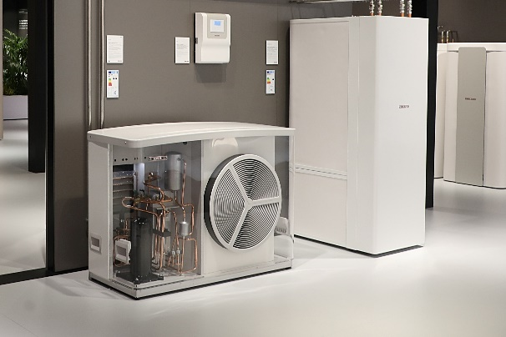 |  | European Environmental Bureau: Heat Pump Manufacturer STIEBEL ELTRON is "Leader" of the Energy Transition 2023

If required, please contact the following person:
STIEBEL ELTRON:
Henning Schulz
Leiter Unternehmenskommunikation
Tel.: +49 (0) 55 31 / 70 29 56 85
henning.schulz@stiebel-eltron.de

